 | 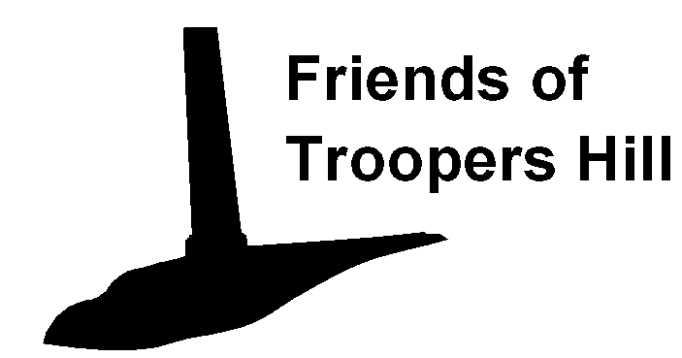 |  |  |  |  | Work Party Information and Registration Form
 | Our Work Parties on Troopers Hill are a fun way of helping maintain the environment of the site for everyone’s benefit. However, we have to ensure that the work we do is carried out safely. We therefore ask everyone joining our Work Parties for the first time to read the following information and to complete the tear off form at the bottom of the sheet.

Risk Assessments

For each Work Party a representative of Bristol City Council together with the Work Party Leader will have carried out an assessment of any possible risks from the work we are undertaking. These will include risks from the location of the site and from the tools that we will be using. They will then have considered the measures needed to reduce the chances of injury. You will be briefed on this assessment at the start of each Work Party and will be asked to sign a form to state that you will comply with its requirement. By following this procedure you will be covered for any injuries by Bristol City’s accident insurance.

Clothing and Footwear

Clothing should be suitable for the weather conditions, please be aware that your clothing may get dirty or snagged on brambles etc. we also recommend that you wear long trousers even on summer days to protect your legs from scratches or insect bites.

Much of the work that we shall be undertaking will be on steep slopes and rough ground, you should therefore wear stout boots or walking shoes. Steel toe capped boots maybe a requirement for certain activities, so please wear these if you have them.

We shall have a limited number of thorn proof gloves available, but it would be appreciated if you can bring your own gardening gloves, you may also find these more comfortable.

Children

Children under 16 are welcome on our Work Parties, but they must be accompanied by an adult who is willing to take responsibility for them at all times.

 | Contact and Medical Details  There will be a qualified 1st Aider on site and a 1st Aid kit to deal with minor injuries. However, in the unlikely event of hospital treatment being necessary we would need to contact somebody to let them know what has happened, we therefore require a contact name and phone number.  It is also important that the work Party Leader knows of any medical or other condition that may affect your ability to carry out certain tasks or affect the treatment you may need in the event of an accident. Please let us know of anything you feel might be relevant, this information will be kept confidential. For insurance reasons please also let us know if you are over 75 years old. |  |  |  |  |  |  |  |  |  |  |  |  |  | Tear here
Name |  |  |  |  |  |  | Address
 | Emergency Contact: Name |  |  |  |  |  |  |  |  |  | Tel
 | *I have no known medical conditions that may affect my participation in Work Parties.
 | *Work Party Leaders should be aware of the following medical or other conditions:
 | Signature |  |  |  |  |  |  |  |  | Date
 | *Please Delete as Appropriate |  |  |  |  |  |  | Friends of Troopers Hill  Tel 0117 947 5037  works@troopers-hill.org.uk

