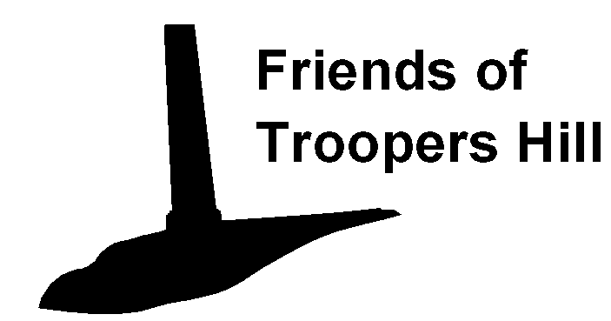
Work Party Health and Safety Plan

Introduction

The Friends of Troopers Hill are committed to ensuring that all works are carried out safely and with minimum risk to both volunteers and the public.

This Plan describes the specific arrangements that will be made to ensure that this is achieved.

Co-ordination and Consultation with Bristol City Council

Troopers Hill is owned by Bristol City Council and all works will be carried out with the Council’s knowledge and consent.

The principle contacts within the Council are:

Local Nature Reserve Officer Sally Oldfield Tel 0117 922 4429

Community Parks Manager Gary Ratcliffe Tel 0117 922 3719

Friends of Troopers Hill Organisation

The Friends of Troopers Hill Works Party Organiser, Rob Acton-Campbell, will be responsible in consultation with the Council's representatives for deciding on tasks to be undertaken and for ensuring that this plan is complied with.

Rob's contact details are:

Address: 3, Corkers Hill, St George Bristol BS5 8DT Tel: 0117 947 5037

For each Work Party a Work Party Leader will be appointed, this could be a member of the Friends of Troopers Hill or a Council employee. This appointment will be approved by the Council's representative. The Work Party Leader shall have attended a course on the Health and Safety aspects of the type of work to be undertaken.

Members of the Friends of Troopers Hill who have under gone training for tasks involving hand tools only are:

Rob Acton-Campbell
Susan Acton-Campbell
Sue Fowden
Carole Edwards
Norman Spalding
Virginia Spalding

Each Work Party shall also be attended by a qualified first aider, who shall ensure that a first aid kit and mobile phone are available for use in emergency.

Members of the Friends of Troopers Hill who are qualified first aiders are:

Rob Acton-Campbell First Aid at Work Valid to Feb 2007
Andy Wilcox First Aid at Work Valid to Aug 2006

Risk Assessments

The Council will carry out risk assessments for all activities on the site in accordance with its own procedures.

The content of these assessments will be discussed with the Friends of Troopers Hill Work Party Leader, who will also be given copies.

The Work Party Leader will be responsible for carrying out any further risk assessments relating to the specific tasks and the specific work locations that they consider necessary. Copies of these assessments will be passed to the Council prior to works commencing.

Work Party Leaders Duties

At the start each Work Party the Work Party Leader shall identify himself and brief all those attending on the following:

The identity of the qualified first aider;
The tasks to be undertaken;
The risk assessments and the control measures to be implemented;
The use of any tools supplied for use at the Work Party (Tool talks);
The procedure in event of accidents.

The Work Party Leader shall ensure that everyone has understood the information given and ensure that the attendance sheet is signed.

The Work Party Leader will also ensure that everyone has completed a Work Party Registration Form. This form asks for emergency contact details for each person and for details of any medical conditions that might be relevant to that person’s participation.

Procedure in event of accidents

In the event of any accident the Work Party Leader's first priority is to ensure that any necessary first aid treatment is given and the emergency services contacted if necessary.

If hospital treatment is not required but the person is unable to continue working then that person should be accompanied home.

In the event of hospital treatment being necessary the person given as an emergency contact or a relative must be informed.

All accidents must be reported to Sally Oldfield or Gary Ratcliffe at the earliest opportunity and entered in the Council's accident book.

Any major accidents should be reported to the HSE Incident Centre:

Telephone - 0845 3009923 or via their web site (http://www.riddor.gov.uk/)

